ORGANIZATIONAL CHART INFORMATION
If your organization has a current organizational chart, feel free to use that one for documentation. If you need to make one, USU employees have access to software from Lucidchart that will allow you to construct a basic chart. You will need to create an account and there are some limitations, as it’s a free version of the software, but will work for most needs. The software can be accessed here https://www.lucidchart.com.
An organizational chart shows the internal structure of an organization or company, creating a clear visual depiction of the hierarchy and ranks of different people, jobs, and departments that make up the organization. The employees and positions are represented by rectangles or other shapes, sometimes including photos, contact information, or page links. For USU purposes please provide, at the least, names and titles.
Straight or elbowed lines link the levels together. A solid line indicates a formal, direct relationship between an employee and his/her direct supervisor. The supervisor provides primary guidance to the employee, including planning, assigning, and scheduling work, reviewing work and ensuring quality standards, overseeing productivity, and conducting performance appraisals.
A dotted line indicates a coordinating or secondary relationship between an employee and a secondary supervisor who provides additional oversight and guidance to the employee in the execution of his/her work. The dotted-line demonstrates that that supervisor has the authority to provide some level of influence and leadership over the employee, such as providing input regarding the employee’s performance to the solid-line supervisor.
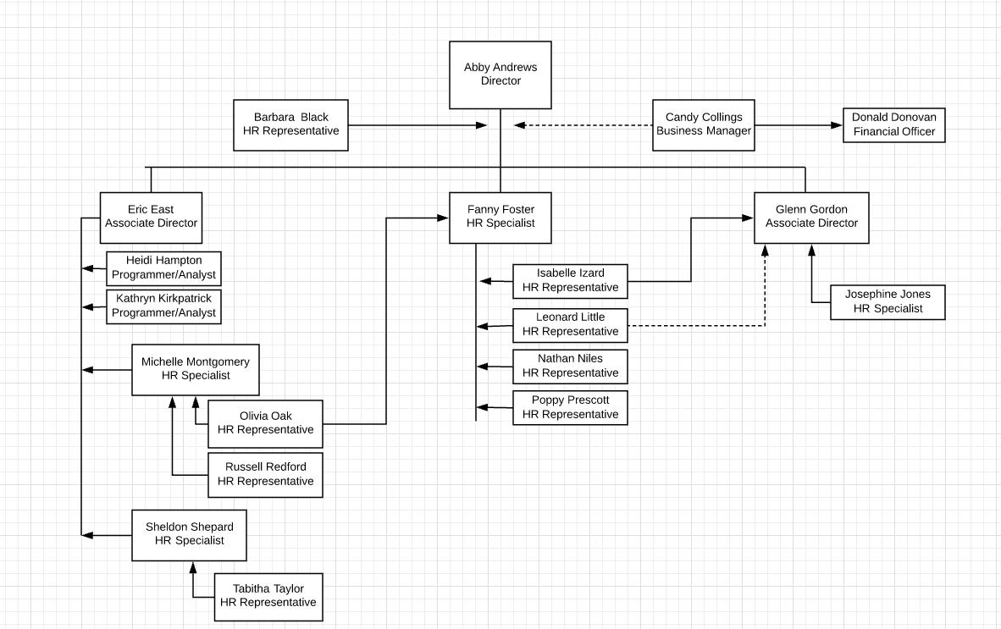

If you have questions or need guidance with the process feel free to reach out to Tanner Hivner (797-1813) or Alyson Fairchild (797-1151) in the HR office.

