VARIOUS CROPS
FEEDER ALFALA
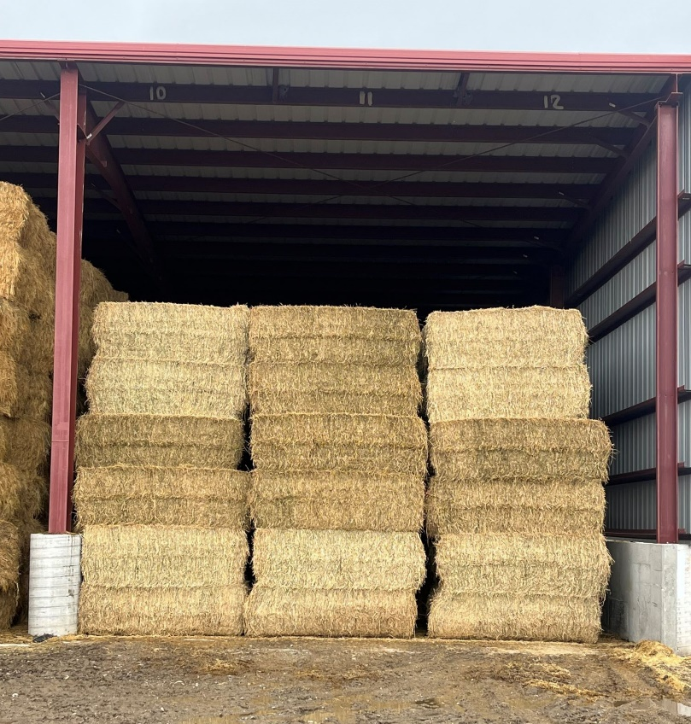
$100.⁰⁰/TON
(Minimum 10 Ton)

Payment made at Surplus Sales then contact Devin Hillyard for Loading – Show payment receipt at time of pick-up. Must Weigh on a Certified Scale and Provide Weight Ticket

